RM Scores Analysis – API Implementation
Name: Yatharth Singh Vikal
Date: 14-01-2026

1. Objective
The objective of this task is to calculate and expose Relationship Manager (RM) performance scores based on recorded evaluation data. The final output provides the top RMs ranked by average score, along with their best and worst scores, grouped by zone and region.

2. Data Sources
The solution uses the following PostgreSQL tables:
- recorded_info
Contains RM evaluation data stored in JSON format (score_json).
- user_master
Contains RM metadata including zone and region.
The tables are joined using the common key rm_id.

3. Approach
- PostgreSQL is used for data aggregation and JSON parsing.
- The final_score value is extracted from the JSON field using jsonb operators.
- Aggregate functions (AVG, MAX, MIN) are applied per RM.
- Results are grouped by zone, region, and RM ID.
- A FastAPI application exposes the result through a REST API endpoint.
- Database credentials are securely handled using environment variables.

4. SQL Query Logic
The following logic is applied in the SQL query:
- Extract final_score from the JSON structure in score_json
- Convert the extracted value to numeric
- Compute:
  - Average RM score
  - Best (maximum) score
  - Worst (minimum) score
(Final SQL query is provided below)

SQL Query :
SELECT
um.zone,
um.region,
r.rm_id,
AVG(
(r.score_json::jsonb
-> 'summery_score'
-> 'data'
->> 'final_score'
)::numeric
) AS avg_rm_score
FROM investigen.recorded_info r
JOIN investigen.user_master um
ON r.rm_id = um.rm_id
WHERE r.score_json IS NOT NULL
AND um.zone IS NOT NULL
AND um.region IS NOT NULL
GROUP BY
um.zone,
um.region,
r.rm_id
ORDER BY avg_rm_score DESC
LIMIT 10;

SQL Query screenshot (in pgAdmin4):
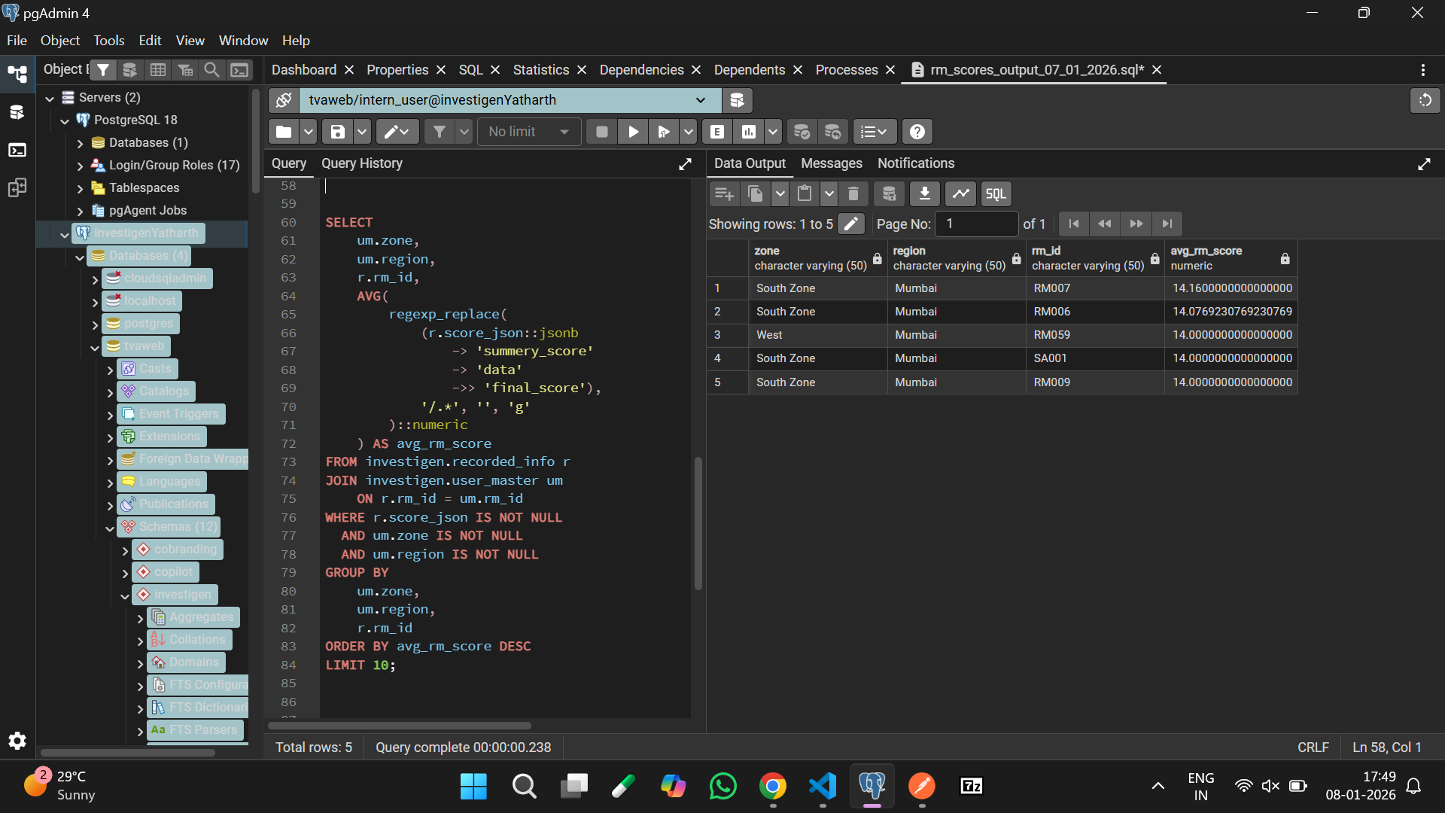

5. API Implementation
- Framework: FastAPI
- Database Driver: psycopg2
- Output Format: JSON
- Endpoint: GET /rm-scores
The API establishes a database connection, executes the query, and returns the aggregated RM score data.

6. Security Considerations
- Database credentials are not hardcoded.
- Credentials are loaded from environment variables using a .env file.
- This approach ensures sensitive information is not exposed in the source code or repository.

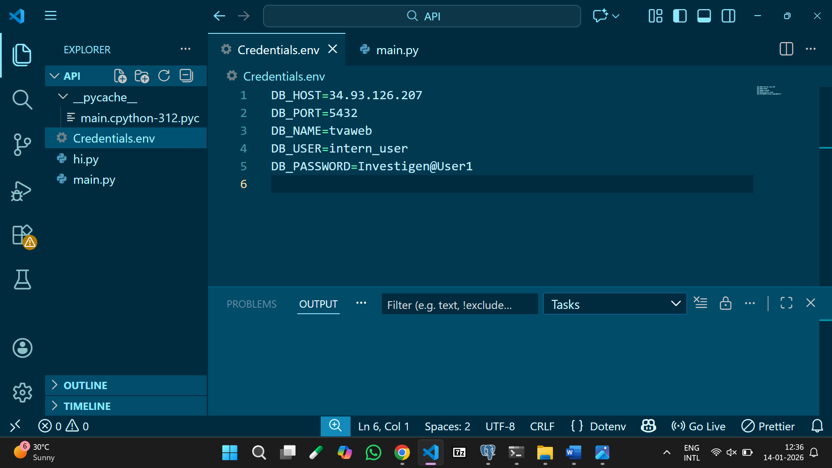

7. Output and Results
The API returns the following fields:
- Zone
- Region
- RM ID
- Average RM Score.

API Response screenshot :
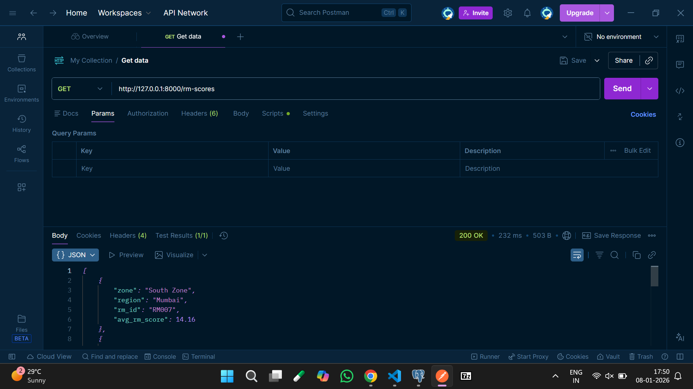

8. How to Run the Application:
- Set database credentials using environment variables.
- Install required dependencies.
- Start the server:
uvicorn main:app --reload
- Access the API at:
URL : http://127.0.0.1:8000/rm-scores

9. Conclusion
The task was successfully completed by aggregating RM performance scores from the database and exposing the results through a RESTful API. The solution is secure, reproducible, and adheres to standard backend development practices.

